Multi-Method Approach to Deciphering Rongorongo
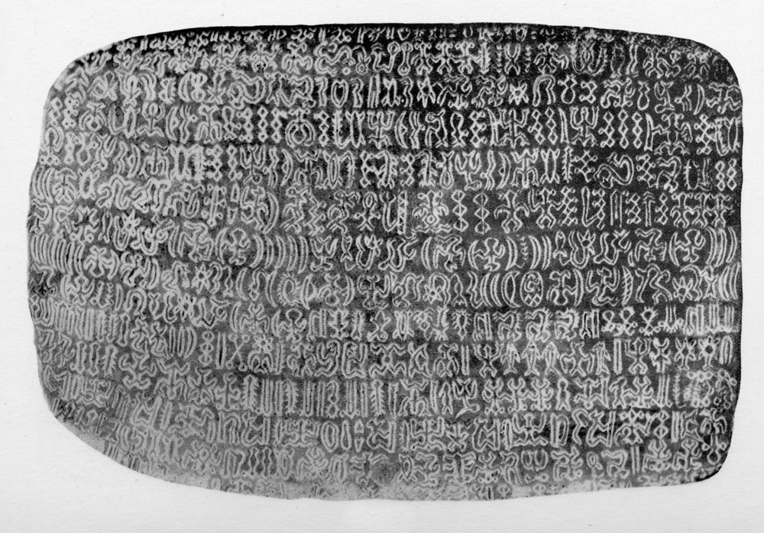
Side A of the Mamari rongorongo tablet (Text C), one of the best-preserved inscriptions from Easter Island. This tablet contains a repeated sequence of glyphs that has been partially deciphered as a lunar calendar[1][2].

Recognizing Patterns: The Lunar Calendar on Tablet Mamari
One of the first breakthroughs came from identifying repeated patterns in the Mamari tablet’s text. In the 1950s, Thomas Barthel noted a sequence of glyphs spanning roughly two and a half lines (on side a, lines Ca6–Ca8) that displayed a highly regular, repetitive structure[3][4]. This sequence consists of about 30 repeated glyph clusters, suggesting an ordered list. Subsequent research confirmed that these 30 units correspond to the 30 nights of a lunar month in the traditional Rapa Nui (Easter Island) calendar[5][6]. In other words, Mamari’s text was not random glyphs, but an enumeration of each night of the month – making it the only Rongorongo text whose function has been confidently ascertained so far[1].
Within this calendrical sequence, several internal patterns stand out. The glyph for the moon (often a crescent-shaped sign) appears in every cluster, sometimes modified or accompanied by other signs. The sequence is structured into eight sections, each preceded by a short delimiter group of glyphs (highlighted in purple in some analyses) that repeats eight times throughout the list[5]. These delimiter groups seem to mark subdivisions of the month (perhaps weeks or phases) – a pattern strikingly similar to how oral Polynesian lunar calendars were recited in segments[5][7]. Notably, the midpoint of the sequence features a special glyph denoting the full moon, around which the pattern of glyphs changes symmetry[5]. In fact, researchers observed that an associated fish glyph flips orientation halfway through the list: the fish is drawn with its head up in the first half and down in the second half, corresponding to the waxing vs. waning moon nights[8][9]. This ingenious use of orientation provides an internal clue that the text is tracking the lunar cycle – the upward fish marking rising (waxing) moon nights and the inverted fish marking setting (waning) moon nights[10][9].
Beyond orientation, some glyphs in the delimiter sequences are miniaturized or distinctive, hinting they serve as “annotations” rather than main entries. Jacques Guy proposed that these small adjunct signs might be phonetic clues or observational instructions embedded in the text[8][1]. For example, two instances of a tiny crescent glyph (a superscript variant) appear in the delimiter groups; Guy speculated these might signal times when the moon’s apparent size should be measured (at apogee or perigee) to decide if an extra night should be added to the month[11][12]. In this way, the Mamari calendar text could double as an astronomical almanac – not just listing night names but telling when to insert intercalary nights (extra nights) based on observation[13][11]. This multi-level pattern (repeating sequences, orientation cues, and special markers) gave scholars a strong foothold for decipherment, since it clearly aligns with the known structure of lunar months.

Cross-Referencing Glyphs with Rapa Nui Night Names
Identifying the calendar pattern was only the first step – the next was to attach meaning to each glyph cluster by using external knowledge of Rapa Nui culture and language. Fortunately, 19th–20th century ethnographers had recorded the traditional Rapa Nui lunar night names. Multiple independent sources (Thomson 1886, Métraux 1930s, Englert 1940s) documented lists of ~28–30 night names in the Rapa Nui lunar month[14][15]. These lists were remarkably consistent, differing only in whether two extra nights (called Hotu and Hiro) were included or omitted – Thomson’s informants gave 30 names, Englert’s only 28, which hinted that Hotu and Hiro were intercalary nights added in longer months[16][15]. This detail matches the Mamari text’s structure of “28 + 2” nights[5][6], reinforcing that the tablet’s content is indeed the lunar calendar.
By aligning the position of each glyph cluster in the sequence with the known order of night names, researchers could cross-reference and make educated guesses about glyph meanings. They found striking correlations between the name of a night and the visual form or accompanying sign of its glyph cluster on the tablet:
- Ata (Night 1, the new moon): Means “shadow” or “obscured” – fittingly, the corresponding glyph is a plain dark crescent (new moon invisible)[17]. This night was considered the moonless night.
- Ari (Night 2, first visible crescent): Means “clarity, whiteness.” On the tablet, the crescent glyph for Ari is accompanied by a looped, barbed appendage[18]. Ethnographic accounts describe a ceremony at first crescent where white feathered strings (heu-heu or maru) were displayed[19]. The barbed loop glyph likely depicts those feathered strings, symbolizing the “white” new moon ceremony and linguistically matching Ari (“white”)[19].
- Kokore 1–6 (Nights 3–8, the unnamed nights): In all the sources these six nights after Ari were simply numbered “Kokore one, Kokore two, … Kokore six,” kokore being glossed as “nameless” or “without substance”[20]. On the tablet, six consecutive crescent glyphs appear with no additional symbols – just plain crescents one after another[20]. This perfectly matches the idea of six “blank” or routine nights with no special name or event, exactly as kokore implies.
- Hua (Night 10, around the first quarter moon): Means “fruit” or “egg” (also a slang for a swollen shape) in Polynesian languages. The glyph for Hua features a crescent with a small rounded attachment, described as looking like a “prickly fruit or bulge”[21]. This visual pun corresponds to the meaning of Hua as a swelling fruit and also aligns with the first-quarter moon’s bulging shape.
- Atua (Night 11): Means “god, deity.” In the Mamari text, the glyph for Atua is a crescent with a peculiar “bulge” (as if pregnant) and is accompanied by a shape resembling a feather cloak[22]. High chiefs and gods in Polynesia often wore feather cloaks, so the glyph seems to iconographically signify a sacred or royal figure, consistent with Atua (god)[22]. In Thomson’s and Métraux’s lists, night 11 Atua is immediately followed by an extra night named Hotu, meaning “to bear fruit”[23]. Correspondingly, the tablet shows an anomalous extra glyph cluster after Atua (present in some repetitions and not others), which likely represents Hotu, the intercalary night inserted before full moon when needed[15].
- Maure (Night 12): This name stumped scholars until Jacques Guy noticed the glyph depicts what looks like an animal’s penis attached to the crescent[24]. Guy boldly hypothesized a phonetic pun here: Maure could be segmented as ma-ure, “with penis” in old Rapa Nui, which the glyph literally shows[24]. In other words, the scribe may have drawn a penis as a clue to the sound ure (penis), reinforcing the reading “ma-ure.” (This proposal of a visual pun is debated, but it illustrates the kind of phonetic reasoning being applied[25].)
- Omotohi (Night 15, the full moon; also called Motohi): The glyph for the full moon is unique and complex. It portrays what has been identified as the “Cook in the Moon” – a pan-Polynesian folklore image of a person in the moon[26]. In the glyph, a small human figure is shown sitting in profile, with three small round shapes underneath. Ethnographers explain that Polynesian cultures see a figure in the full moon tending an earth-oven; the three round shapes are the stones of the oven (umu)[26]. The Mamari glyph is literally depicting this mythological cook, confirming it as the full moon symbol.
- Orongo (Night 23, third quarter moon): Means “(moon) going down” or is related to the word rongo (to recite/announce). On the tablet, the crescent for Orongo is accompanied once again by a barbed string-like glyph (very similar to the one for Ari)[27]. Katherine Routledge noted that in Rapa Nui tradition, ceremonies with white feathered sticks were held not only at the new moon but also at the last quarter moon[19][27]. The presence of that same symbol here ties the glyph to the Orongo night and its ritual.
- Orongo taane (Night 24): In Métraux’s list this night is “Rongo Tane,” literally “male Orongo.” Fittingly, the Mamari glyph for this night is accompanied by a small figure of a frigate bird[28]. The Rapanui word for the frigate bird is taha (similar in other Polynesian languages), whose first syllable ta suggests “Tane” (which starts with Ta)[28]. Scholars believe this bird glyph was used as a phonetic complement to cue the reader that this Orongo is the ta(ne) variant[28]. It’s an elegant example of how a symbol (bird = taha) can provide a sound hint (ta) to distinguish similar names.
These examples illustrate the multi-method decipherment at work: the tablet’s repetitive pattern told us it was a calendar; the ethnographic records of lunar night names gave us a likely meaning for each position; and the shapes of the glyphs themselves often corroborated the meanings through iconography or provided phonetic wordplay. By cross-referencing all these inputs, researchers achieved a partial reading of the Mamari text – essentially “translating” many glyph compounds to their corresponding night names or functions in the lunar cycle[29][26]. The Mamari tablet thus became the Rosetta stone for Rongorongo, proving that at least in this case the script encoded the Rapa Nui language or concepts in a systematic way.

Extending the Method to Other Tablets
Having deciphered the general content of the Mamari calendar, scholars next looked for similar patterns in other Rongorongo texts. The idea is to apply the same multi-method approach – pattern analysis, internal clues, and external cross-reference – to see if other tablets contain known sequences (such as calendars, genealogies, or chants).
One promising case is Tablet Keiti (Text E). Analysis of Keiti’s recto (front side) reveals it is highly structured: certain glyph sequences repeat many times across the lines[30]. Recent structural studies by Melka (2008) and others identified three main repeating patterns on Keiti, nicknamed sequence alpha, sequence beta, and sequence gamma. Sequence alpha appears 10 times, sequence beta appears 7 times (often back-to-back), and sequence gamma 10 times, dispersed through the text[30]. The fact that large groups of glyphs recur so often strongly suggests a list or tabular content – not unlike the repetitive list of nights on Mamari. Researchers noticed moreover that sequence gamma (the 10-time repetition) is actually embedded within the longer alpha sequences each time[31][32]. This hints that alpha is a higher-level structure that includes gamma, much as the Mamari calendar’s sections included a recurring sub-sequence.
What could these Keiti sequences mean? By analogy to Mamari, scholars hypothesized that Keiti might be recording lunar months rather than days – essentially an extended calendar covering many months (possibly a year or more). Indeed, Keiti’s repeated patterns have a prominent crescent glyph (glyph 040/041) that alternates orientation, similar to the waxing/waning moon markers on Mamari[33]. In one interpretation, each repetition of sequence alpha on Keiti corresponds to one month, and within it, certain glyphs indicate whether that month had the extra nights Hotu or Hiro added[33][34]. For example, a right-facing crescent in a particular position might mean “include Hotu this month,” while a left-facing crescent means “skip Hotu”[33]. When researchers ran through all ten alpha sequences on Keiti with this assumption, the total count of nights came to 295 nights – which is almost exactly 10 × 29.5, the length of ten lunar months[35]. This is a remarkable result: it suggests Keiti’s text may be listing ten consecutive lunar months with their lengths, achieving an average of 29.5 days per month (which matches the lunar cycle)[35]. In other words, Keiti’s scribe could have been recording a year’s worth of moons, using the same principle discovered in Mamari!
To illustrate, one decoded segment of Keiti’s pattern was read as: “Add night Hotu and don’t add night Hiro to the month of X”[34]. The following glyphs (in the sub-sequence gamma) might then spell out the name of that month or its position in the year[36]. Early researchers have proposed that certain glyph combinations on Keiti correspond to Rapa Nui month names or even the word for “month” itself. For instance, sequence gamma – which repeats in Keiti – is thought to mean either “month” (Rapanui marama) or “year” (Rapanui matahiti), because its composition of glyphs can plausibly be read as MA-TA-HI-TI phonetically[37][38]. One glyph in gamma looks like a frigate bird, which, as on Mamari, likely signifies TA (from taha, bird)[38]. Another glyph resembles an obsidian blade (mataa), hinting at MA[38]. By this reasoning, a glyph string “MA-TA-HI-TI” could be hiding in plain sight as a combination of signs – a compelling hint that Keiti’s repeated sequence is about time periods (months or years).
Beyond Keiti, cross-table comparisons have turned up other recurring phrases that bolster the decipherment effort. For example, after the end of the Mamari lunar list, there is a short sequence of glyphs (beginning with signs numbered 520-70 in Barthel’s catalog) that does not belong to the night list itself. Intriguingly, this same 520-70 sequence appears on another line of Mamari (side b) and even on a different tablet (Tablet B, Aruku Kurenga, line Bv2)[39]. The fact that an identical phrase is found on multiple tablets suggests it was a common formula or refrain – perhaps a standard invocation or conclusion related to the calendar or ritual. By identifying such repeated formulas across texts, researchers can guess their purpose (for instance, a closing prayer, a title, or a genealogy introduction) even if the exact translation is uncertain.
Speaking of genealogies, another multi-method clue came from Tablet G (Small Santiago). In the 1950s, Russian epigraphers Butinov and Knorozov noticed that a portion of tablet G (line Gv6) contained a regularly repeating pattern, almost like “A – B, B – C, C – D…” in structure. They boldly suggested this could be a genealogical list, where a phrase like “X son of Y” or “X begat Y” would naturally create a chain of overlapping repetitions (…Y – Z, Z – W…)[40]. This was one of the earliest attempts to assign meaning to a Rongorongo text using pattern structure alone. While we cannot directly confirm the content without a key, later analysts have found the genealogy hypothesis plausible and consistent with Rongorongo’s repetition patterns[41]. If correct, it means Tablet G might be tracing a lineage or sequence of chiefs. This approach draws on external logic (the fact that Polynesian cultures often had genealogical chants) combined with internal repetition analysis to propose a viable meaning.
Not all early theories have stood the test of cross-method scrutiny. For instance, Dr. Steven Fischer once hypothesized that the Santiago Staff (a long wooden staff covered in glyphs) contained repetitive “procreation triads” – phrases naming a man, woman, and offspring, repeated throughout the text[42]. This idea was based on a presumed pattern, but when researchers applied a rigorous structural analysis, they found too many exceptions and inconsistencies for Fischer’s reading to hold up[43]. In fact, over 40% of the supposed triads didn’t fit the pattern[43]. The multi-method approach helps here as well: a purely pattern-based reading that lacks support in linguistic or cultural context is likely to be a false lead. As more scholars weighed in (Pozdniakov, Guy, Sproat, etc.), the consensus was that Fischer’s “procreation formula” was not valid[42]. This underscores the importance of cross-verifying patterns with external evidence – the same way we verified Mamari’s pattern against known moon names. Only when all lines of evidence converge do we gain confidence in a proposed decipherment.

Synthesis: Toward the “Best of All Worlds” Interpretation
By combining all three approaches – pattern analysis, linguistic/cultural cross-reference, and comparative context – modern researchers have made significant strides in understanding Rongorongo. The Mamari tablet’s lunar calendar was deciphered by recognizing a repetitive structure (pattern), then correlating it with Rapa Nui lunar nomenclature (language/culture), and even identifying visual/phonetic cues in the glyphs themselves (internal context). This multi-method synergy provided a partial Rosetta Stone for Rongorongo, yielding the first confirmed readings of glyph sequences[1][4].
We then applied the same methodological toolkit to other texts like Keiti and found they too likely encode calendrical or astronomical information, just on a larger scale (months and possibly years instead of days)[35][36]. The identification of repeating sequences on Keiti and their successful alignment with a 29½-day month cycle is a triumph of pattern analysis reinforced by the lunar calendar model from Mamari[35][33]. Similarly, cross-referencing motifs (like the crescent+bird sign for Rongo Tane, or the reappearance of Mamari’s end-phrase on other tablets) shows that Rongorongo texts did not exist in isolation – they share common lexicons and perhaps genres across the corpus[39][44].
Each approach alone has limitations: pure statistical or pattern analysis might yield multiple hypothetical readings; blind linguistic guessing can be far-fetched without structural support; and one-to-one glyph-to-word matching fails if the script is logographic or mixed. But by blending all approaches, we narrow the possibilities. For example, pattern analysis might tell us a section is a list of names, external lore might tell us what lists of names to expect (gods? chiefs? stars?), and then specific glyph imagery might clinch the identification (a glyph shaped like a fish appearing in a sea-god list, etc.). In the case of the lunar calendar, this three-pronged strategy produced a coherent reading that aligns with astronomy, Polynesian culture, and the glyphic artwork itself – truly the “best of all worlds.”
It’s important to note that Rongorongo is still not fully deciphered – far from it. Outside of the calendar, most passages remain opaque, and even the calendar itself has lines whose details are debated[45][46]. Old Rapa Nui (the likely language of the texts) is only partially reconstructed, and the corpus of texts is small and contextless[47]. However, the progress on the Mamari tablet gives a blueprint for moving forward. Researchers now scour the other tablets for analogous structures (for instance, sequences of crescent glyphs that might indicate another calendar or lists of other cyclical events). Some studies have looked into possible star calendars or lists of seasons using similar methods, examining if certain repetitive patterns might align with known star names or monthly rituals. Others focus on identifying logographs – e.g. if a particular glyph consistently appears next to a turtle glyph (perhaps indicating the word honu for turtle), could that be a sign for the deity associated with turtles? Each hypothesis is tested against pattern frequency, cultural context, and cross-table occurrence.
In summary, the multi-method decipherment approach – fusing statistical patterns, ethnographic linguistics, and comparative analysis – has proven to be the most powerful strategy in cracking Rongorongo’s code. It enabled us to read the Mamari lunar calendar with considerable confidence[4][26], and it continues to guide the interpretation of other texts like Keiti’s possible month-by-month record[35][48]. By systematically applying this strategy, tablet by tablet, and cross-checking clues (the “best of all three worlds”), scholars inch closer to unlocking the full narratives encoded in Rongorongo. Each new insight – whether it’s a recurring phrase identified on multiple artifacts or a clever visual pun hinting at a syllable – adds a piece to the puzzle. The work is painstaking and ongoing, but with each round of multi-method analysis, we refine our understanding of how this unique script recorded the life and knowledge of the Rapa Nui people[1][40]. The hope is that one day, all these partial decipherments will coalesce, and the silent wooden tablets of Easter Island will finally “speak” their long-forgotten tales.
Sources: The analysis above is based on a synthesis of epigraphic studies and ethnographic records, including Barthel’s foundational identification of the Mamari calendar[3], Guy’s detailed linguistic and astronomical commentary on the calendar glyphs[9][13], and recent structural analyses of other tablets by Horley, Melka, Pozdniakov and others[30][34]. These sources, among others, provide the empirical evidence connecting Rongorongo’s internal patterns with the Rapa Nui language and cultural context, demonstrating the effectiveness of a combined-methods decipherment approach.

[1] [2] [5] [8] [10] [44] Rongorongo text C - Wikipedia
https://en.wikipedia.org/wiki/Rongorongo_text_C
[3] [6] [9] [13] [14] [15] [16] [17] [18] [19] [20] [21] [22] [23] [24] [26] [27] [28] [29] TABLET MAMARI
https://web.archive.org/web/20080313061033/http://www.netaxs.com/~trance/mamari.html
[4] [7] [25] 1 Drawing of lines Ca5-9 of Tablet C (Mamari), containing the so-called... | Download Scientific Diagram
https://www.researchgate.net/figure/Drawing-of-lines-Ca5-9-of-Tablet-C-Mamari-containing-the-so-called-list-of-the-nights_fig1_383862124
[11] [12] [39] [45] [46] Lunar calendar in rongorongo texts and rock art of Easter Island
https://journals.openedition.org/jso/6314
[30] [31] [32] [33] [34] [35] [36] [37] [38] [40] [41] [42] [43] [47] [48] Astronomical Content in Rongorongo Tablet Keiti
https://journals.openedition.org/jso/6272?lang=en

